LAB EXPERIMENTS

INDEX
S.NO | EXPERIMENTS | PG.NO. | T. SIGN
1. | Consider following databases and draw ER diagram and convert entities  and relationships to relation table for a given scenario:  COLLEGE DATABASE
2. | Consider following databases and draw ER diagram and convert entities  and relationships to relation table for a given scenario:  COMPANY DATABASE:
3. | Database Schema for a customer-sale scenario
4.
5.
6.

EXPERIMENT 1
Consider following databases and draw ER diagram and convert entities
and relationships to relation table for a given scenario:
COLLEGE DATABASE:
STUDENT (USN, SName, Address, Phone, Gender)
SEMSEC (SSID, Sem, Sec)
CLASS (USN, SSID)
SUBJECT (Subcode, Title, Sem, Credits)
IAMARKS (USN, Subcode, SSID, Test1, Test2, Test3, FinalIA).

ER DIAGRAM
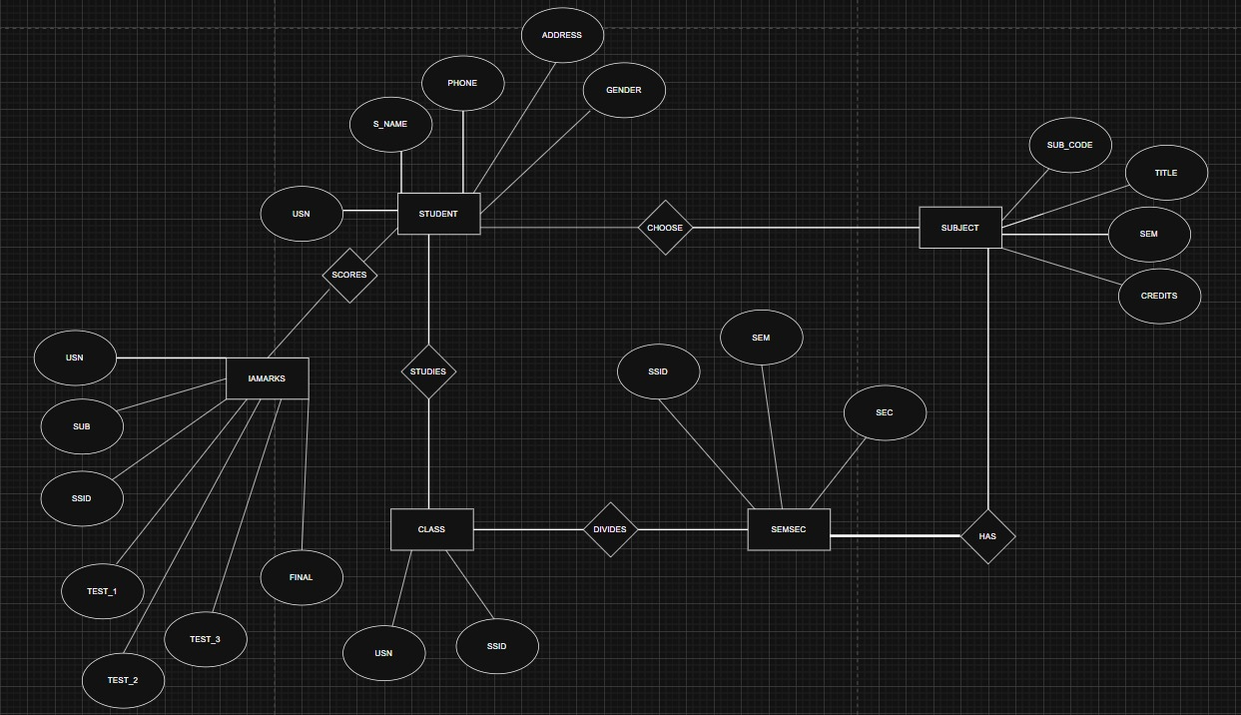
EXPERIMENT 2
Consider following databases and draw ER diagram and convert entities
and relationships to relation table for a given scenario:
COMPANY DATABASE:
EMPLOYEE (SSN, Name, Address, Sex, Salary, SuperSSN, DNo)
DEPARTMENT (DNo, DName, MgrSSN, MgrStartDate)
DLOCATION (DNo,DLoc)
PROJECT (PNo, PName, PLocation, DNo)
WORKS_ON (SSN, PNo, Hours).

ER DIAGRAM
